
SUPERIOR UNIVERSITY GOLD
CAMPUS

- Name: Muhammad Abdullah
- Department: BS Artificial Intelligence
- Section: BSAI-3A
- Subject: AI (Lab)
- Submitted to: Sir Rasikh
- Roll no: SU92-BSAIM-F25-022

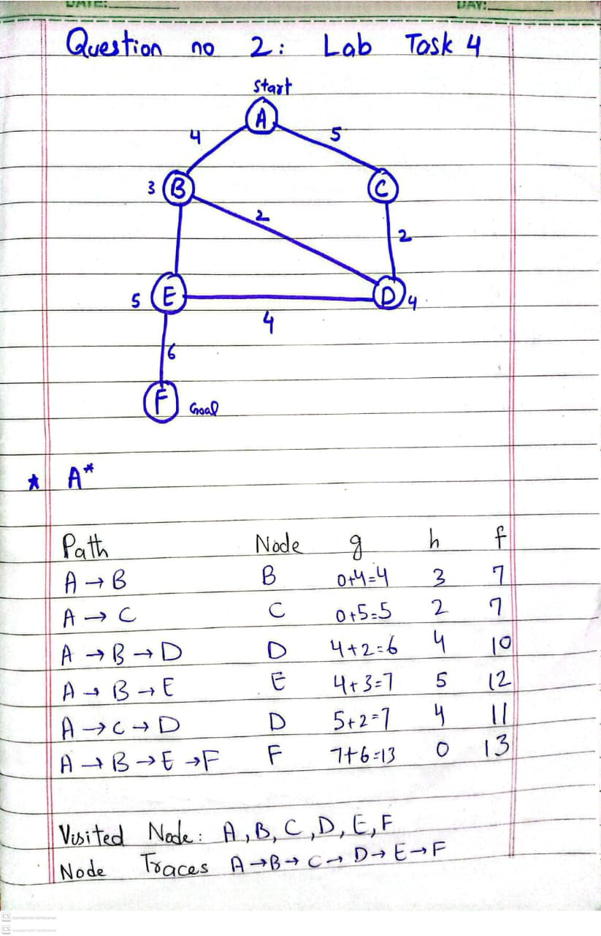
Lab Task 4
(Question 2)
